HIGH-LEVEL DESIGN DOCUMENT

**DOMESTIC POWER CONSUMPTION DATA ANALYSIS AND REPORTING USING POWER BI**

**Version: 1.0**

**Created Date: 17/03/2023.**

Revision History

|  |  |  |  |
| --- | --- | --- | --- |
| Version | Date | Created By | Reviewed By |
| 1.0 | 17/03/2023 | Jayachandra Babu |  |
|  |  |  |  |
|  |  |  |  |
|  |  |  |  |
|  |  |  |  |

TABLE OF CONTENTS

Contents

1. Introduction 4

1.1 Purpose 4

1.2 Scope 4

2. System High-Level Design Overview 4

2.1 System High-Level Design Goals, Scope, and Objectives 4

2.2 High Level Architecture 5

3. System Design Consideration or Approaches 5

4. Deployment / Reporting 5

# Introduction

## Purpose

This document provides a comprehensive architectural overview of the Domestic Power Consumption Data. The document describes Circle wise units’ distribution and load.

## Scope

The Scope of POC is Importing Raw data into Azure SQL Database to Visualise using Power BI which includes the scenarios related to Power Consumption Data – Circle wise Units Distributed and Load. The visualization report also provides the insights related to the Load and Units distributed each year.

The dashboard provides single point of view to analyze the TS-State business and build business strategy and future decisions.

# System High-Level Design Overview

## System High-Level Design Goals, Scope, and Objectives

**Scope:**

The Scope of POC is Importing Raw data into Azure SQL Database to Visualise using Power BI which includes the scenarios related to Power Consumption Data – Circle wise Units Distributed and Load. The visualization report also provides the insights related to the Load and Units distributed each year.

The dashboard provides single point of view to analyze the TS-State business and build business strategy and future decisions.

**Objective:**

The Company wants to Import Raw Data into Azure SQL Database.

## High Level Architecture

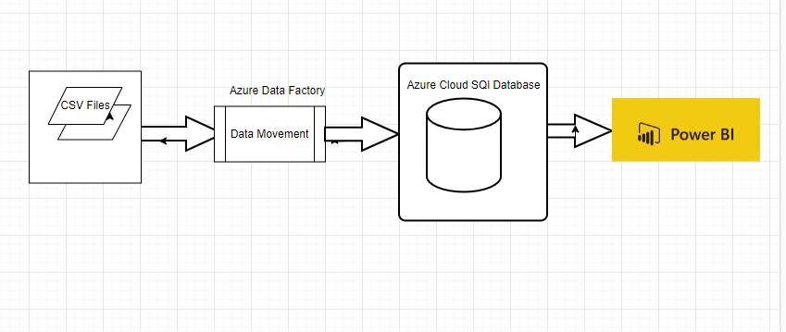

# System Design Consideration or Approaches

Our Approach is Azure Data Factory (ADF) with SQL Cloud Storage

We will build a data flow in ADF to load Raw files, and then build a pipeline to move the data into the Azure SQL cloud database.

For reports to be generated, we will use Azure SQL cloud database with Azure linked services or Power BI

# Deployment / Reporting

Over all data showing the scenarios related to Power Data – Circle wise units’ distribution and load. The visualization report also provides the insights related to the Units and load distributed each year.

-------End of the Document------